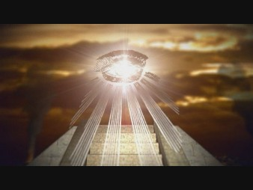

***Banking and Money Group***

International Money Center Banks

Central Banks

International Monetary Fund (IMF)

World Bank

International Bank of Settlements

World Conservation Bank

Multi-National Corporations

Foundations

***Secret Society Groups***

Bohemian Clubs

Freemasonry

Skull & Bones

Grand Orient Lodge

Grand Alpina Lodge

Knights Templar

Royal Order of the Garter

Priory De Sion

Rosicrucian’s

***Political Group***

National Government Leaders

United Nations (7 Headed Beasts)

Bilderbergers

Trilateral Commission

Council on Foreign Relations (CFR)

Club of Rome

Aspen Institute

Bohemian Grove

Regional Federations (NATO, SATO, EEC, etc..)

International Labor Unions

***Education Group***

UNESCO

World Peace Groups

Planetary Congress

World Federalist Association

& Parliamentary Association

Environmental Groups

Lucis Trust

World Goodwill

World union

Esalen Institute

Media Establishment

***Religious Group***

World Council of Churches (WCC)

National Council of Churches (NCC)

World Parliament of Religions

Vatican/ SMOM

New Age Cults & Groups

Liberal Protestants (Apostate Church)

Unity Church

Unitarian/ Universalist Church

Baha’i

Temple of Understanding

***Intelligence Group***

CIA

KGB

Israeli Intelligence

British Intelligence

Mafia & Organized crime

Drug Cartels

Interpol

Communist Party